Assembly procedure of the Smart Clamp linear motor

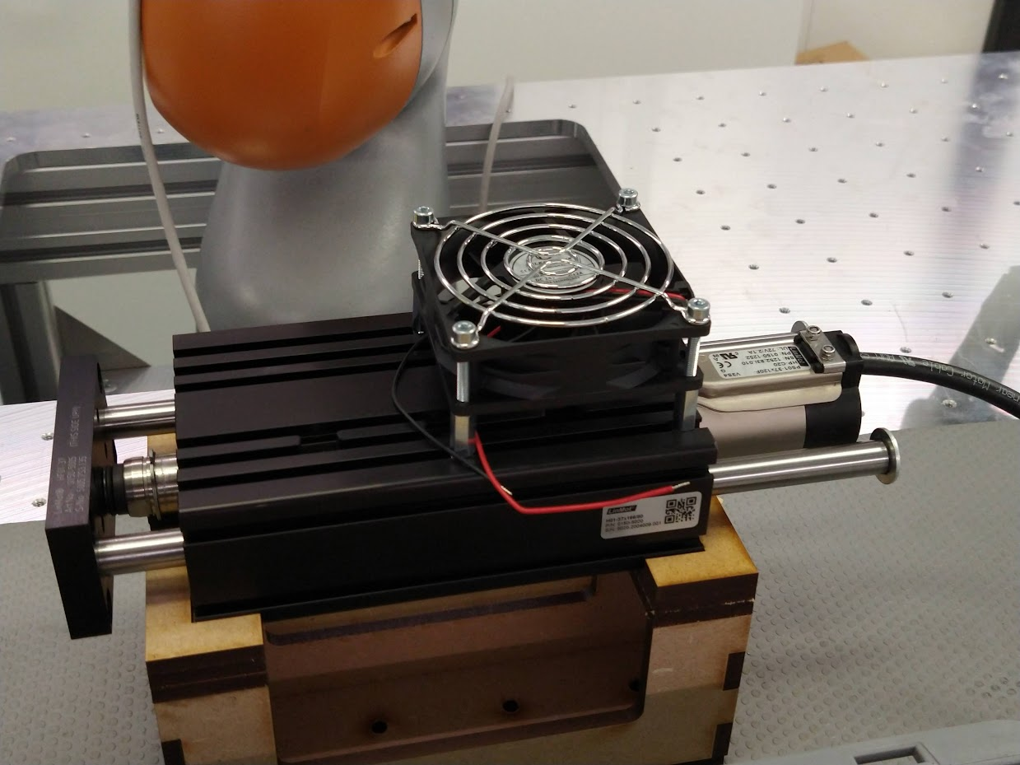


Safety precautions
Tools
The following tools and supplies are required for performing the assembly procedure:
- Hex key (size 3)
- Hex key (size 4)
- Hex key (size 5)
- Fixture

Parts
The following parts are required for performing the assembly procedure:
- 1x Slider screw M8x25 (DIN 7984)
- 2x Spherical washer M8 (DIN 6319c)
- 2x Shaft screw M6x12 (ISO 4762)
- 1x Front plate (0150-5005)
- 2x Conical seat M8 (DIN 6319d)
- 1x Dished washer 16/8,2/0,9 (DIN2093A)
- 1x Slider (0150-1506)
- 2x Hardened steel shafts for ball bearings (0150-5010)
- 3x Clamping screw M5x18 (ISO 4762)
- 3x Clamping cylinder (0150-5053)
- 1x Guide block with ball bearings (0150-5002)
- 1x Stator (0150-1252)
- 2x Washer M6 20/1,5
- 2x Shaft screw M6x12 (ISO 7380)
- 1x Brake hole cap (0160-0727)
- 1x Cooling fan 80x80mm
- 4x Square nut M4 (DIN 562)
- 4x Hexagonal spacer M4x16
- 4x Screw M4x30 (ISO 4762)
- 1x Protective grid

Start the assembly procedure
- Make sure the assembly kit is available on the work table.
- Grab the black guide block from the table and position it in the fixture with the T-slots upwards and the 3 holes towards you.
- Grab the stator from the kit.
- Slide the stator carefully in the housing from the right side.
- Fix the stator in the housing:
  - Grab three clamping cylinders from the container on the table
  - Grab three clamping screws M5x18
  - Insert the clamping cylinders completely and put a screw in each of them.
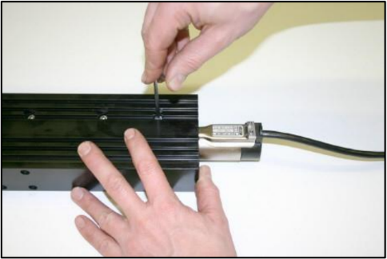
  - Use the hex key (size 4) to fasten the screws.
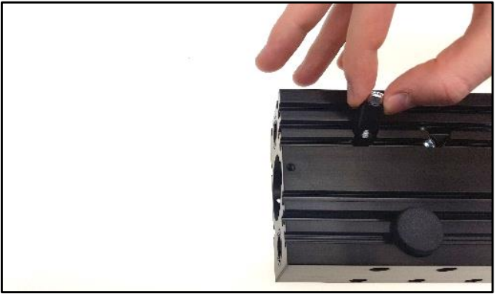
- Grab the brake hole cap from the container and push it in the hole on the guide block.
- Assemble the slider:
  - Grab the tube with the slider from the kit.
  - Open the tube and carefully extract the slider rod. It is highly magnetic, so grasp it firmly.
  - Insert the slider into the stator from the left side. You’ll notice some resistance resulting from the magnetic effects.
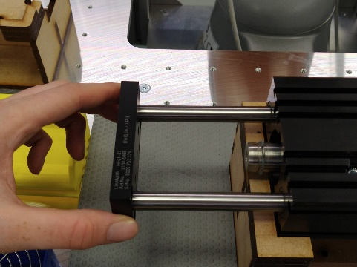
  - Put the tube back in the kit.
- Insert the hardened steel shafts in the guide block from the right side.
- Put the front plate against the two shafts.
  - Make sure ‘This side up’ is visible after mounting. The text should be oriented towards the housing.
  - Fix the front plate to the shafts by using the two shaft screws M6x12 and the hex key (size 5).
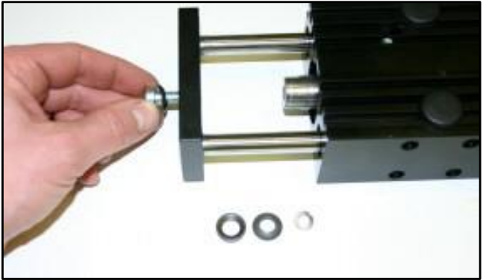
- Prepare the slider screw:
  - Grab the slider screw M8x25 from the container.
  - Grab 2 spherical washers, 1 conical seat and 1 dished washer from the container.
  - Place the spherical washer on the slider screw and insert it into the front plate. The conical seat is milled into the front plate.
- Attach the front plate to the slider:
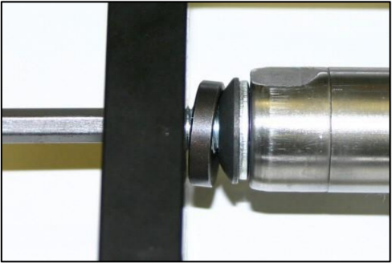
  - Place the conical seat, the spherical washer and the dished washer on the other side of the front plate onto the slider screw.
  - Screw the bolt into the slider rod end. Use a hex key (size 5) for this.

Assemble the fan for additional cooling
- Grab 4 square nuts M4 and 4 hexagonal spacers M4x16 from the containers on the table.
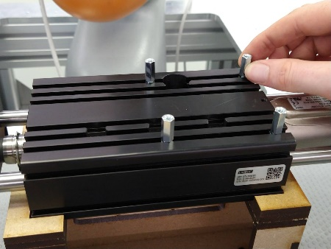
- Assemble spacers:
  - Slide the 4 square nuts into the T-slots on the guide block in the correct positions.
  - Screw the 4 hexagonal spacers onto the square nuts.
- Put the cooling fan on top of the spacers and adjust the spacer position if necessary.
- Put the grid on top of the cooling fan.
- Assemble cooling fan
  - Grab 4 screws M4x30 from the container on the table
  - Fix the 4 screws using the hex key (size 5)
- The assembly is finished.

